
052400-1 VU Information Management and Systems Engineering (2025W)
Milestone 2
(Please note: submission deadline: Tue 20.01.2026 13:00)
Group X
Student 1: <last name>, <first name>, <matriculation number>
Student 2: <last name>, <first name>, <matriculation number>
(Please note: sort by last name)
[DATE], Vienna

1 Milestone 1 – Recap and Revisions 3
1.1 Recap: ER-Diagram 3
1.2 Revisions and Changes 3
2 Milestone 2 3
2.1 Infrastructure – Team 3
2.2 RDBMS Implementation 3
2.3 NoSQL Implementation 4

Milestone 1 – Recap and Revisions

Recap: ER-Diagram
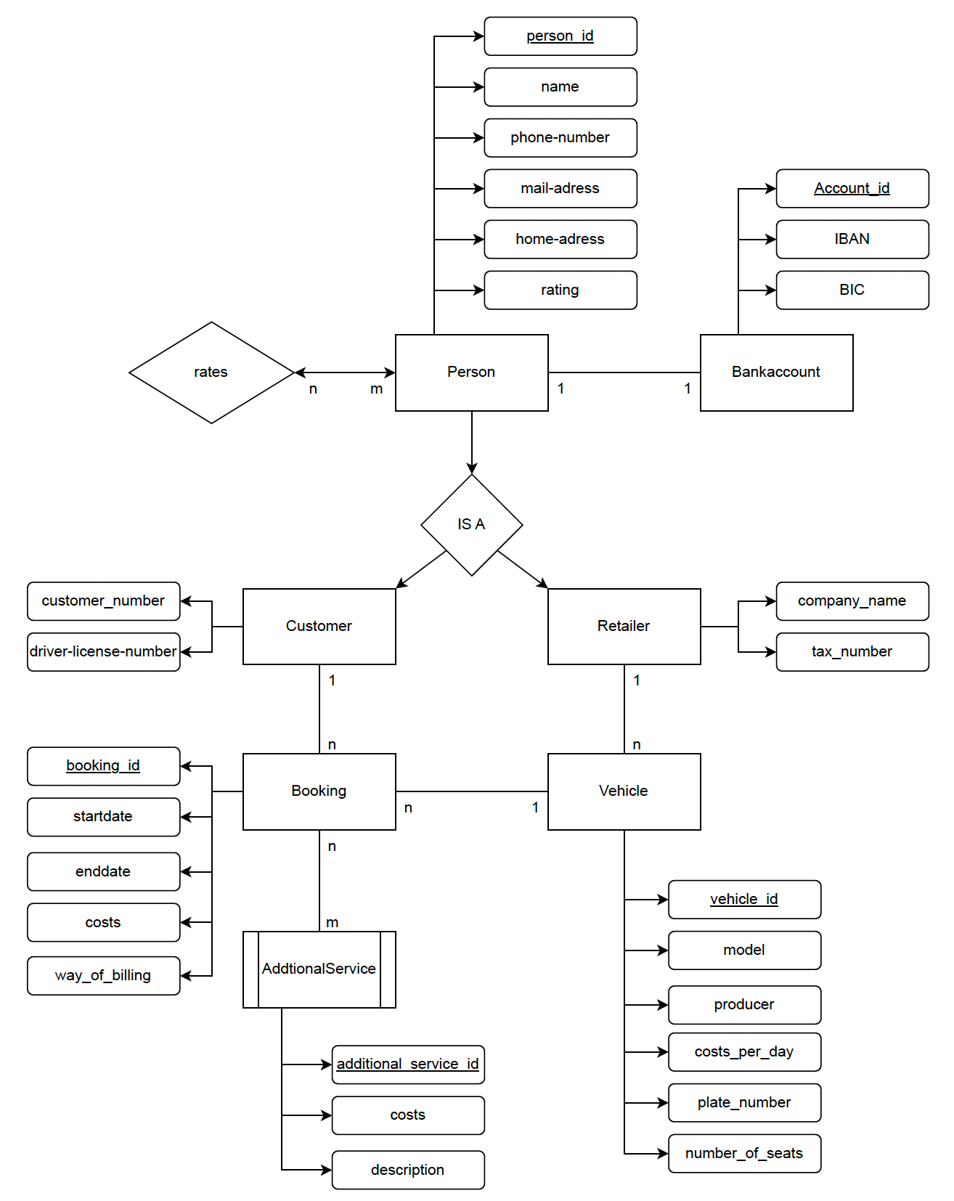

Revisions and Changes
None

Milestone 2

Infrastructure
The app runs as three Docker Compose services.
WEB UI: http://localhost:8080
MariaDB is initialized from ‘./seed/Create_Tables.sql
MongoDB for NoSQL Use Cases
Run instructions:
Docker compose build
Docker compose up
Open the UI at http://localhost:8080.
To generate the SQL Data: click “Generate Data in the UI”
To generate MongoDB data: click “Migrate to NoSQL

RDBMS Implementation

DB Setup / Data Import / Base Function of Web System
The database schema is created using SQL “CREATE TABLE statements based on the ER model. Foreign key contraints are used-
The data is improted via a SQL script “generate_data.sql”. It generates and inserts test data for all entities, except Booking and Bokkings_Service.

Change to Milestone 1:
None

STARS IN PERSON???

Student 1

Implementation of the Use Case and the Analytics Report
Use Case: The customer creates a reservation for a vehicle
The goal of the report is, to show the booking with an id, customer, vehicle, period, day, base-cost, additional_cost and the total costs. Further it can be filtered by data range or vehicle_id.
Outcome: After the use case is triggered in the web system. The report includes the new booking and updates the booking history.
Changes: none
Student 2

Implementation of the Use Case and the Analytics Report
Briefly describe the goal of your use case and report, including how the report’s outcome changes after the use case is triggered in the web system. Note any changes to the use case or analytics report since Milestone 1.

NoSQL Implementation

NoSQL Re-Design
Person
{
"_id": "customer1",
"name": "Alice Example",
"phone_number": "066287327",
"eMail": "alice@example.com",
"address": "Main Street 1",
"stars": 4.5,

"roles": {
"customer": {
"customer_number": "C-1001",
"driver_license_number": "AB1234567"
},
"retailer": null
},

"bankAccount": {
"account_id": "ba1",
"iban": "AT611904300234573201",
"bic": "BKAUATWW"
}
}

BOOKINGS
{
"_id": "b1",
"start_date": "2026-01-05",
"end_date": "2026-01-10",
"way_of_billing": "CreditCard",

"customer": {
"person_id": "p_cust1",
"name": "Alice Example"
},

"vehicle": {
"vehicle_id": "veh1",
"model": "Fiesta",
"producer": "Ford",
"costs_per_day": 70.0
},

"retailer": {
"person_id": "p_ret1",
"company_name": "Blue Cars Ltd."
},

"additionalServices": [
{ "service_id": "as1", "description": "ChildSeat", "costs": 20.0 },
{ "service_id": "as4", "description": "FullInsurance", "costs": 50.0 }
],

"pricing": {
"total_costs": 0
},

"createdAt": "2026-01-01T10:00:00Z"
}

Vehicles:
{
"_id": "veh1",
"model": "Fiesta",
"producer": "Ford",
"costs_per_day": 70.0,
"plate_number": "W-AB123C",
"number_of_seats": 5,
"retailer_id": "p_ret1"
}

Rating:
{
"_id": { "rater_id": "p_cust1", "rated_id": "p_ret1" },
"stars": 4.8
}

{
"_id": "as1",
"description": "ChildSeat",
"costs": 20.0,
"active": true
}

The goal of the NOSQL design is to support both team members use cases and analytics reports. Data is organized around booking. Compared to the MS1 Milestone the NOSQL Design has been adapted. Bank accounts are now embedded within the person and additional services are embedded in bookings. Also a service catalog collection has been introduced
Primary keys form the RDMBS are replaced by MongoDB’s _id fields. Foreign keys are replaced by reference fields. This improves flexibility and scalability.
An alternative would be to store only references in bookings an rely on multiple lookups. This would reduce redundancy, but increases the number of joins and I/O operations required for reports

Persons:
stores the base data of all people, Roles and bank accounts are embedded and this reduces additional red operations and avoids unnecessary joins
Vehicles:
Stores vehicle data. Vehicles are referenced in retailers, because one retailer can own many vehicles.
Additional services:
Represents the catalog of available additional services. Are stored separately because they are selected by the user and must be loaded independently. This supports the second use Case
Bookings:
Central aggregate of the application. Basis in both use cases. They embed the selected additions service and store snapshots of relevant customer, vehicle and retailer attributes. Denormalization reduces the number of reads and lookup operation during report.
Ratings:
Stores ratings between persons. Own collection, because the relation can grow over time and not always required when loading a person document

NoSQL DB Setup and Data Migration
Briefly describe the DB setup and data migration process, outlining the steps taken to transfer data from one system to another.

Student 1

NoSQL Use Case and Analytics Report
The use Case is implemented via “/api/nosql/usecase1/customers”, “/api/nosql/usecase1/vehicles, and “/api/nosql/usecase1/bookings. Ther report is provided by “/api/nosql/usecase1/customers, which aggregates the booking documents and computes base, additional, and total costs. In comparison with 2.2, after clicking on button “Migrate to NoSQL”, the NoSQL report returns the same business results as the SQL report. Different is only the data access.

NoSQL Analytics Report Statement
The report is only executed on the bookings collection. Each booking document has embedded data from customer, vehicle and additional services. So we need no joins. And we can generate the aggregation with an aggregation pipeline.
A compromise is, that customer and vehicle data are duplicated. If in another document changes for example the customer’s name or vehicle price it’s not ensured, that this is automatically updated.
But in our case, a booking is only a snapshot, which shows the data at the time of the reservation. So it’s acceptable.
A further challenge was type inconsistency. During, migration, some fields appeared as strings instead of numeric values, which can break arithmetic operators. To mitigate that, I convert the daily price and additional service cost to numeric types. If there is an error or null, the values are set to 0 to ensure calculating costs remain correct.

NoSQL Indexing
See guidelines

Student 2

NoSQL Use Case and Analytics Report
Briefly summarize the NoSQL implementation of the use case and report, and compare their results/outcome with those from 2.2.

NoSQL Analytics Report Statement
See guidelines

NoSQL Indexing
See guidelines

